# PAC-POLY-LEEWARD ISLANDS (SOCIETY) Raiatea Bora Bora Tahaa-Cook 1769

## Chart of the Society Isles Discoverd by Captn Cook 1769

35 cm x 21.5 cm copperplate engraving, 38 cm x 24 cm sheet size, Alexander Hogg, London, 1785

We are pleased to offer this scarce and historically important original chart of the principal Leeward Islands of the Society Islands in what is now French Polynesia compiled by Captain James Cook on his first voyage of discovery in 1769 and engraved for the *New, Authentic, Entertaining, Instructive, Full and Complete Historical Account of Captain Cook's First, Second, Third and Last Voyages*[1](http://vi.vipr.ebaydesc.com/ws/eBayISAPI.dll?ViewItemDescV4&item=251599080451&t=1406232706000&tid=10&category=37961&seller=regiomontanus&excSoj=1&excTrk=1&lsite=0&ittenable=false&domain=ebay.com&descgauge=1" \l "1) published serially between 1784 and 1786.   Cook's chart is centred on Raiatea and Tahaa, with Bora Bora, Huahine, Maupiti and Tupai on the perimeter.  Recognising that the islands were already named by the native inhabitants he decided these original names should be retained (Ulietea was a variant name for Raiatea) but decided to name the group of islands as a whole as the Society Islands, recording in his journal:

"Ulietea, Otaha and BolaBola [are] so call'd by the Natives and it was not thought advisable to give them any other names but these three together with Huaheine, Tubai, and Maurua as they lay contiguous to one another, I have named Society Isles "2

Beautifully engraved with delicate yet quite elaborate hachure work for topography this example is enhanced with fine hand colour work including a lovely cyan wash for littoral waters and will make a elegant presentation if matted and framed and an important addition to any collection related to the explorations of James Cook.

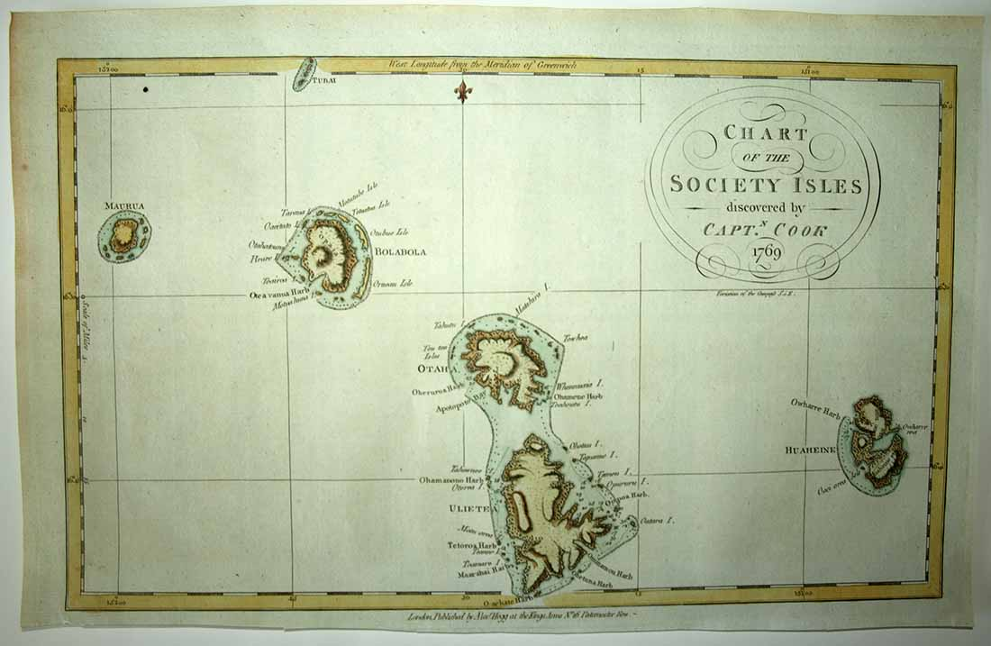

Note careful depiction of rocks and shoals, depth soundings, anchorages - Cook and his crew considered charting a responsibility to future mariners to warn of dangers and as a solemn duty.  To get a sense of chart detail consider that the distance from "Ohamene Harbour" on Tahaa (Otaha) to the coast of Huahine as seen below measures just 12 cm actual size:

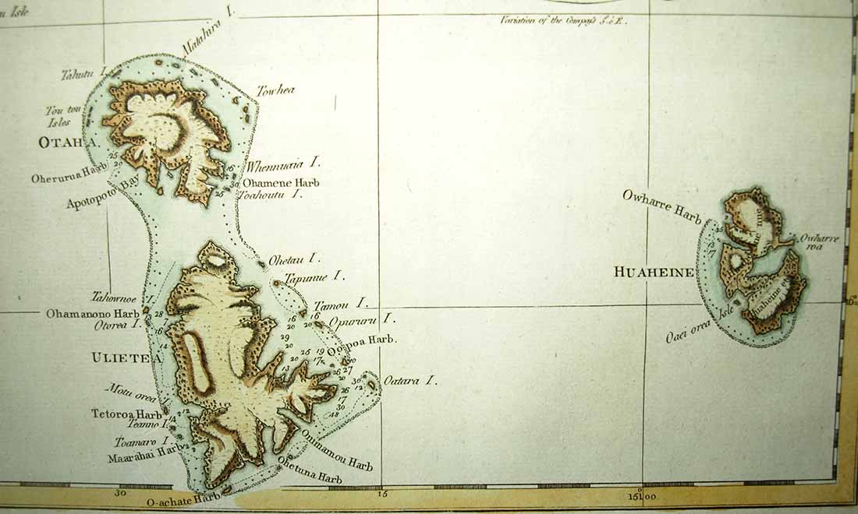

Cook often mistook the soft Tahitian "P" sound for "L" and hence, "Bola Bola":

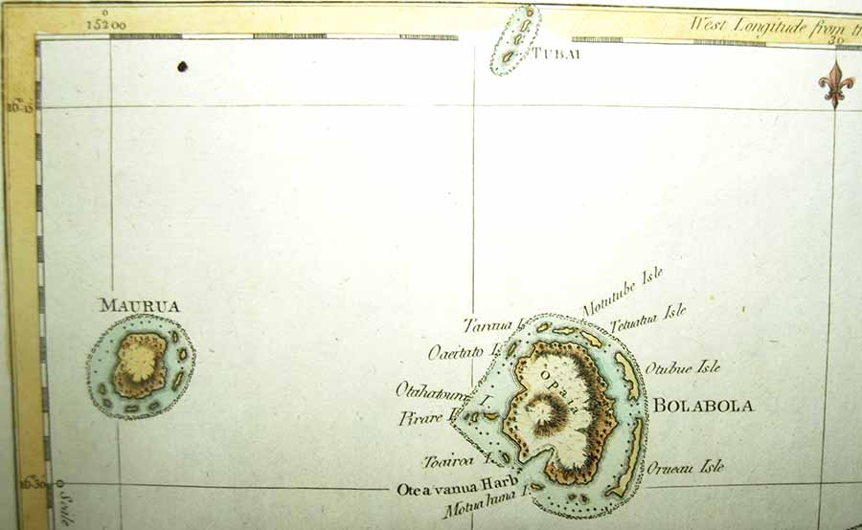

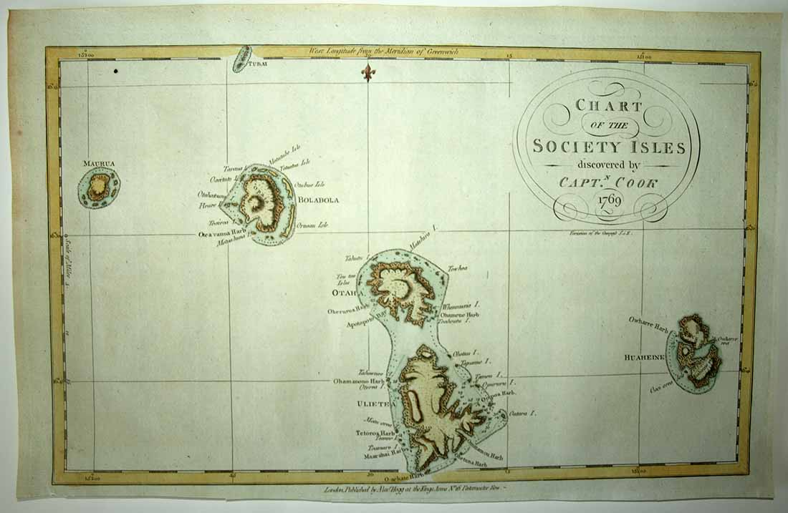

# Condition - Please note carefully:  The chart is in overall very good condition as can be ascertained from photos, strong impresssion with distinct platemark on fine quality laid paper, very fine hand colour work, no text on verso, no folds.  Chart exhibits a small dark spot in upper left corner as can be evaluated in photos and otherwise the image area is essentially pristine.  Some trivial light browning to margin edges with a close and slightly uneven trim to bottom margin; image of print shows it lying flat in free state with all edges shown for evaluation.  [Inquiries](mailto:jfazli@ix.netcom.com) welcome and we encourage you to visit our other [listings](http://cgi6.ebay.com/aw-cgi/eBayISAPI.dll?ViewListedItems&userid=regiomontanus&sort=3&since=-1) on eBay. NOTES: 1. The editor of the *New, Authentic, Entertaining, Instructive, Full and Complete Historical Account of Captain Cook's First, Second, Third and Last Voyages* was named as one "George William Anderson",  almost certainly a pseudonym for the publisher Alexander Hogg.  In a recent exhibition of these historically important engravings made for this publication the Lowe Art Museum in Miami noted that the pseudonym was "a device Hogg employed in a number of his publications" intended to convey an "aura of authoritative knowledge" regarding his editing of the official publications of the voyages.  Hogg shrewdly elected to publish the work (which eventually included accounts of other circumnavigations) in a relatively affordable serial format from 1784-1786 to reach a broad audience, noting in his marketing copy that this was "due to the many thousands of Persons who would wish to peruse the Discoveries... and view the astonishing fine Copper-Plates, who have hitherto been excluded from gratifying their eager curiosity.  These installments would allow every Person, whatever may be his Circumstances, to read about the voyages of which such vast Sums of the Public Money have been expended." 2. Cook, Journals I, 9 August 1769